**Database Technologies**

**UE19CS344**

**6th Semester, Academic Year 2021-22**

Week #: 4 - LOAD LARGE DATA

(A1)

Date: 15/2/2022

|  |  |  |
| --- | --- | --- |
| Name :  SUMUKH RAJU BHAT | SRN :  PES1UG19CS519 | Section :  H |

**(RDBMS used - postgres**

**Miniworld - Ticket Reservation System)**

1. **DDL for a schema called TICKETS**

Command:

create table TICKETS(tid int, seat_no int, price int, isBooked int, date date, primary key (tid, seat_no));

Output:

Screenshot from 2022-02-15 15-11-23

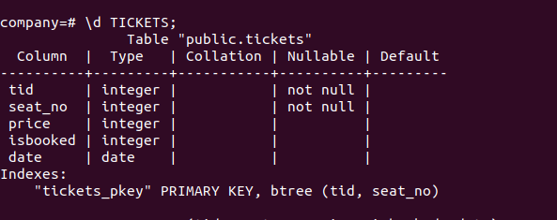

1. **Load large amount of data without insert statement**

Code:

COPY TICKETS(tid, seat_no, price, isbooked, date)

from '/home/sumukhbhat2701/Downloads/myFile0.csv'

DELIMITER ','

CSV HEADER;

Output:

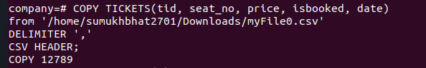

- COPY commands allows PostgresSQL server to move data to/from database tables to standard file system files.

- When using the command, each field in the file is inserted sequentially to the specified column. Table columns not specified in the column list get their default values.

- Files in COPY are read/written directly by the server and not by the client application. Therefore, it must be located on or accessible to the database server machine, not the client either.

- It is necessary to grant SELECT privilige on the table read by COPY to and INSERT previlige in the table where the values are inserted with COPY FROM

- It cannot work for views.

- COPY to and COPY from are the 2 variants of COPY command

- DELIMTER and HEADER options are used in the command to specify the file type.

1. **Explain-analyze**:

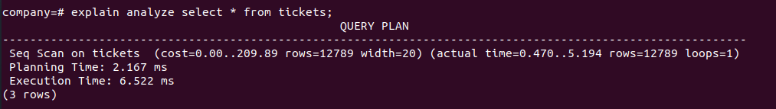

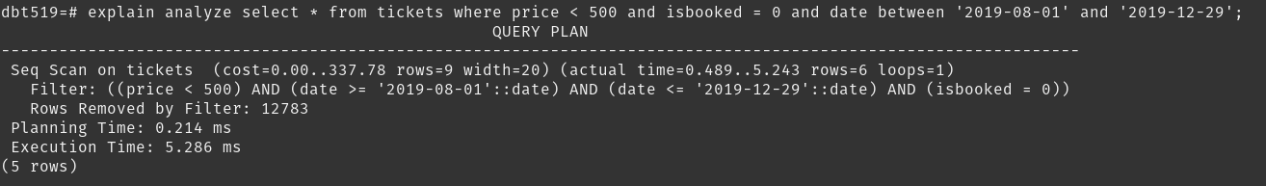Note that it is doing a sequential scan, as there are no secondary indexes setup.

(The 2nd screenshot is one from the next assignments. Change in OS from ubuntu to popOS is the reason for change in terminal background color in the above screenshots)

1. **select count(*) statement:**

Code:

select count(*) from TICKETS;

Output:

